VAJA 10, 11 REALNI TOKOVNI VIR

**1. Besedilo**

V EWB-ju sestavite vezje. Pomerite tok in napetost pri različnih uporih v vezju z tokovnim virom. Izračunajte notranjo upornost, moč bremena, I/I0, U/U0, P/Pmax. Nato na enake upore še izmerite z napetostnim virom.

**2. Merilno vezje**

**Slika 1: Slika 2:**

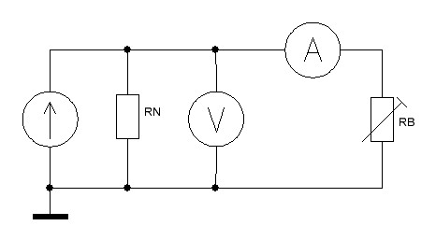 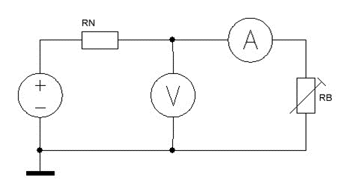

**3. Merilna tabela**

Merilna tabela 1:

|  |  |  |  |  |  |  |  |
| --- | --- | --- | --- | --- | --- | --- | --- |
| *RB* | *U* (V) | *I* (mA) | *RN* | *PB* (mW) | *I/I* | *U/U* | *P/Pmax* |
| 0 | 0.0002 | 200 | / | 0.04 | 100% | 0% | 0% |
| 5 | 0.9526 | 190.5 | 100.3 | 181 | 95% | 5% | 18% |
| 10 | 1.818 | 181.8 | 99.5 | 331 | 91% | 9% | 33% |
| 20 | 3.333 | 166.7 | 100.3 | 556 | 83% | 17% | 56% |
| 50 | 6.667 | 133.3 | 99.8 | 889 | 67% | 33% | 89% |
| 100 | 10 | 100 | 100.1 | 1000 | 50% | 50% | 100% |
| 200 | 13.33 | 66.66 | 99.9 | 889 | 33% | 67% | 89% |
| 500 | 16.66 | 33.33 | 99.9 | 555 | 17% | 83% | 56% |
| 1000 | 18.18 | 18.18 | 100.3 | 331 | 9% | 91% | 33% |
| 2000 | 19.05 | 9.523 | 100.5 | 181 | 5% | 95% | 18% |

Merilna tabela 2:

|  |  |  |  |  |  |  |  |
| --- | --- | --- | --- | --- | --- | --- | --- |
| *RB* (Ω) | *U* (V) | *I* (mA) | *RN* (Ω) | *PB* (mW) | *I/I0* (%) | *U/U0* (%) | *P/Pmax* (%) |
| 0 | 0,0002 | 200 | / | 0,04 | 100 | 0 | 0 |
| 5 | 0,9526 | 190,5 | 100,3 | 181 | 95 | 5 | 18 |
| 10 | 1,818 | 181,8 | 99,5 | 331 | 91 | 9 | 33 |
| 20 | 3,333 | 166,7 | 100,3 | 556 | 83 | 17 | 56 |
| 50 | 6,667 | 133,3 | 99,8 | 889 | 67 | 33 | 89 |
| 100 | 10 | 100 | 100,1 | 1000 | 50 | 50 | 100 |
| 200 | 13,33 | 66,66 | 99,9 | 889 | 33 | 67 | 89 |
| 500 | 16,66 | 33,33 | 99,9 | 555 | 17 | 83 | 56 |
| 1000 | 18,18 | 18,18 | 100,3 | 331 | 9 | 91 | 33 |
| 2000 | 19,05 | 9,523 | 100,5 | 181 | 5 | 95 | 18 |

**4. Enačbe**

$$R_{N}=\frac{-∆U}{∆I}$$

$$P_{B}=U∙I$$

**5. Grafi**

**Graf 1:**

**Graf 2:**

**6. Komentar**

Pri tej vajo smo ugotovili da so rezultati enaki pri napetostnem in tokovnem viru, edina razika je kako vežemo notranjo upornost. Vaja je zelo podobna vajama 8. in 9. samo, da smo vse pri tej vaji naredili v EWB. Cilj vaje je bil, da smo videli razliko med viroma in se naučili uporabljat EWB.